(Approx. 813 words)

LibreOffice Basic Programming using ChatGPT
By Alan German, Treasurer
Ottawa PC Users' Group, Ontario, Canada
Published in Ottawa PC News (August 2023)
https://opcug.ca
brigittelord (at) opcug.ca

ChatGPT (https://chat.openai.com/chat) is an artificial intelligence (AI) tool that, amongst other things, can create text based on a request from an end user. So, I thought I would use it to write an article for the newsletter by entering "Write an article for OPCUG's newsletter on LibreOffice Basic Programming." Had I gone ahead with this, you would now be reading the following:

"LibreOffice is a free and open-source productivity suite that provides several applications, including Writer, Calc, Impress, and Base. These applications are designed to provide a comprehensive set of tools to meet the needs of any user. LibreOffice also comes with a built-in programming language called LibreOffice Basic, which allows users to automate tasks and create custom solutions to enhance the functionality of the suite."

But, first let me explain the scenario. I have a LibreOffice document (ODT file) that contains the lists of topics that have been covered over the past three years in our weekly online Q&A sessions. Each week, I build an agenda for the upcoming session as a simple text file (TXT) that lists the titles of the topics to be discussed next. This text file is used for various purposes, one of which has been manually adding the list of new topics to the main ODT index file. I wanted to automate this latter process by developing a macro that would read the topics from the text file and add them to the end of the ODT file.

I don't know all that much about object-oriented programming, so, when I want to create a macro for a document in LibreOffice Writer, my practice is to use Google to search for code extracts that I can then modify and string together to produce the final product. And, this is precisely what I did to build the required macro in this case.

But then I saw a YouTube video of an individual using ChatGPT to create computer code in a number of programming languages by simply telling the AI bot what was required. Now, perhaps LibreOffice Basic is a bit of a backwater item in terms of mainstream programming, but I figured that it would be worth a shot to see if I could use ChatGPT to develop the code for my macro.

I know how to read and write lines of text from an ASCII file. My problem is that the ODT file isn't a simple text file. The ODT format is a special type of ZIP file that contains a number of XML and other components. So, the trick is to have the macro open the ODT file, identify the component that contains the body text of the document, add the desired lines at the end, and close the file.

At present, it's possible to use ChatGPT at no cost. All that is required is to create an account on the system or login using an established Google account. Once logged in, one enters a request as a string into a text box. My request was "Write a program in LibreOffice Basic to add a string to the end of an odt file."

The result was amazing – as shown, in part, by the following screenshot:

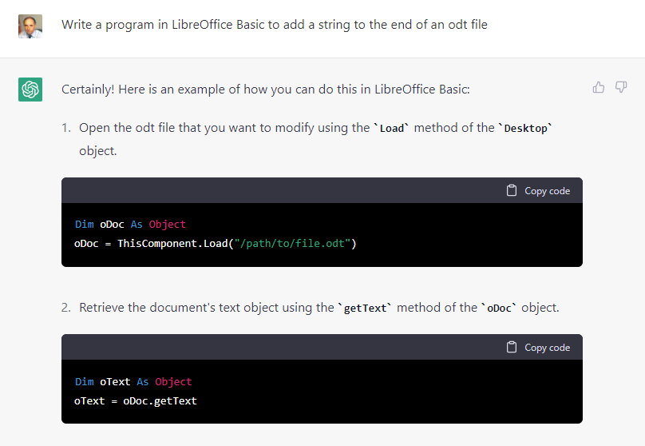

ChatGPT effectively produces a custom tutorial on building the macro. Each required step in the process is explained, and the relevant code extract displayed. Finally, all the code that has been developed for the requested macro is shown as a complete block:

Sub AddStringToODTFile

Dim oDoc As Object
Dim oText As Object
Dim oEnd As Object

' Open the document
oDoc = ThisComponent.Load("/path/to/file.odt")

' Retrieve the text object
oText = oDoc.getText

' Insert the string at the end of the document
oEnd = oText.getEnd
oText.insertString(oEnd, "This is the string that will be
added to the end of the file.", False)

' Save the modified document
oDoc.store

End Sub

In essence, this code segment is very close to the macro code that I had produced over some considerable time, having had to research several web postings to identify the required techniques. Clearly, it is very generic code and only covers part of what is required for the final macro. But, it is evident from this simple test that the AI bot is fully capable of generating "modules" of code that can readily be adapted for the desired purpose and that such modules could be quickly consolidated into a fully functional macro.

The other consideration is that the current version of ChatGPT is at an early stage in the development of AI tools. As such applications become more sophisticated and the computer systems running them become more powerful, it is highly likely that their use in computer programming will become ubiquitous.

Even now, ChatGPT is perfectly capable of developing useful code in a number of popular programming languages. For example, in addition to producing macros for LibreOffice Basic, it is just as easy to develop Python scripts. So, ChatGPT is a useful tool for anyone seriously developing programs, macros, and scripts, and is a really interesting option for those who wish to learn the techniques.

Bottom Line
______________________________________________________________________
ChatGPT (Proprietary, web-based system)
OpenAI
https://openai.com

